**The Shot Heard ‘Round the World: A Statistical Analysis of NBA Offenses, Before and After the Implementation of the 3-Point Shot**

Eric Chen, Noah Mathews, William McMillian

**Abstract:**

This year, Stephen Curry obliterated the made three point record made in a season that he set one year ago. His awe-inspiring performance has caused pundits and fans alike to question whether the basketball of yesterday is the same as the basketball of today. Curry’s ability to make a shot from anywhere on the court has forced defenses to completely adjust their schemes. It seems that one man’s prowess is the driving force behind this change, which is only made possible by the existence of the three point line. The purpose of this paper is to explore the impact the addition of the three point shot has had on the game of basketball. We utilized regression analyses and t-tests to thoroughly comprehend whether a change was present. We ultimately concluded that a change in the pace of the game was happening, but it was not caused by the steady increase of three point shots.

**Introduction**

In 1891, James Naismith accidentally invented one of the most popular sports in the world. His good intentions of keeping school boys occupied eventually created a mutli-billion dollar industry in the United States, and professional leagues in just about every developed country in the world. Though basketball appears to reach new heights as a sport every year, it was not always this popular, and in fact nearly became obsolete.

During the 1970’s, basketball was in a bad place. Basketball’s inventor, James Naismith’s, arbitrary decision to place the at hoop ten feet above the ground had, in time, tailored the sport exclusively to the extremely tall. Basketball was being drained of its excitement. Full games would consist of the smaller players passing the ball to the super-tall players standing under the basket who would then try to put the ball in. The game was too jammed up around the net. Fans lost interest and game attendance fell. Articles were written about how the game was boring, and even worse, dying.

At the time, the dominant professional league, the National Basketball Association (NBA) was trying anything they could to restore fans’ interest in basketball. “People suggested a lot of fixes to make the game more dynamic: no backboard, a convex backboard, a smaller basket, a bigger ball, a smaller ball, a no scoring zone around the basket, and even a height cap, which would work like a [sports team salary cap](https://en.wikipedia.org/wiki/Salary_cap) but using a player’s height instead of wages. None of those changes caught on, but a rival professional basketball league, new to the scene, came along aiming to shake things up with some other fresh approaches. The ABA ([American Basketball Association](https://en.wikipedia.org/wiki/American_Basketball_Association)) had many crazy ideas, including half-time shows with bear wrestling. Most of their ideas didn’t stick. Except for one: the three-point shot.” However creative, the ABA actually stole the three point shot from an an earlier, defunct league, the American Basketball League (ABL); who stole the idea from the NCAA, where it was only used once, in 1945 in a game between Columbia University and Fordham University.

Nonetheless, the three point shot was a success. With all field goals previously being worth only two points, the three-pointer broke up the bunching underneath the basket. By rewarding shots from distance, t allowed basketball to become more dynamic. More importantly the three point shot was entertaining. It excited fans and kids felt that it was something that they could go home and practice. It opened the game up to shorter players that could knock down the perimeter shots. Basketball was no longer just for goons. It was now a sport for everybody.

**Methods:**

In the 2014-2015 season, the Golden State Warriors rocked the NBA with their flex style offense, and Stephen Curry and Klay Thompson’s flashy three point shooting ability. With the most threes shot and made out of any team that year, it was no surprise that they were crowned NBA Champions. Their success caused a slight change in basketball at both the collegiate and professional levels. Offenses changed to incorporate even more three point shooting than in years past, and the game of basketball seemed to be changing. This change in offensive flow and shot taking caught our attention.

We wanted to do a decade-by-decade analysis of the effect the inclusion of the three point point shot had on the NBA. Unfortunately, the method of scoring was only officially instituted at the end of the 70s decade and the beginning of the 80s decade in the 1979-80 season. Therefore, we had to look at years within the decade to be consistent. Additionally, we chose the same few years - fourth year to ninth year - from every decade to ensure the data sets were equidistant from each other. So, we have four data sets: 1974-79, 1984-89, 1994-99, & 2004-09. We did not have a data set for the 2010s decade because the required years have not occurred yet. It should also be noted that the data sets are not equal in size, as the league has been continuously expanding over the years.Thus, we ordered the datasets from greatest Pace to least Pace and took the top 100 entries from each dataset in order to maintain identical sample sizes. This makes doing Matched Pair T-Tests and even the Regression Analyses much simpler and easier to understand.

The independent variables we wanted to use were Two Point Shots Attempted (2PA) and Three Point Shots Attempted (3PA). The main dependent variable we intended to observe was Pace, or possessions a team has in one game. We also selected Offensive Rebounds (ORB) and Assists (AST) as additional statistics we could run linear regression tests against in order to determine whether or not a significant change is present. Basketball-reference proved to be a bountiful source that provided us with all of the variables we were looking for.

We conducted many tests on the data in order to look for trends or any patterns that we wanted. Firstly, we ran regression analysis on the first season of every decade, starting with 1974-1975 and ending with the 2004-2005 season. These seasons were taken to be representative of the decade. The 1974 season was pre-three-pointer, and every season after that was post three-pointer. For the 1974 season, we only took the regression of Pace vs. 2PA, ORB, and AST, while for the seasons after that, we took the regression of Pace vs. 3PA as well in order to compare the effect and correlation of the 3PA on the pace between the decades.

Next, we conducted matched pair T-Tests on the Pace datasets. The comparison was done based on time, so we were hoping to determine conclusively that Pace had been changing over the decades. First, we compared the pace of the 1970s decade to the pace of 1980s decade. We continued to compare consecutive decades all the way to the 2000s decade.

**Results and Analysis:**

The various regression analyses gave us interesting results. In the 1974 regression analysis of Pace vs. 2PA, ORB, AST, we have an R2 value of 0.5059, which means that 50.59% of the variation in Pace is explained by the model based in 2PA, ORB, and AST. In the 1984 season regression analysis of the same variables, we obtained a R2 value of 0.5529, which means that 55.29% of the variation of Pace was explained by a model based in the three variables. For 1994, we obtained a R2 value of 0.4949, and interestingly, for 2004, we obtained a R2 value of 0.0845. This was very interesting because it was a shocking jump from 1994 to 2004, from 49.49% to 8.45%. For some reason, in the 1994-2004 decade, the impact of 2 point attempts, offensive rebounds, and assists on the pace of the game drastically decreased, and so the amount of variation of pace that was explained by these variables was drastically decreased as well. But was the three-pointer related to this at all?

Before we look at the impact of the three-pointer, we will take a look at the regression graphs of the 1974-1994 seasons of Pace vs. 2PA, because 2PA is the most significant factor in the regression model that most affects Pace:

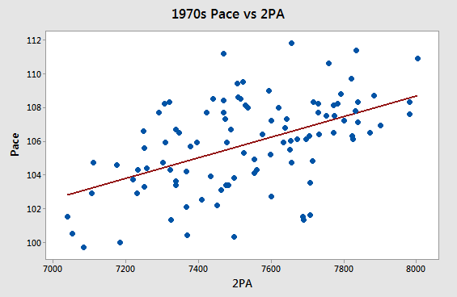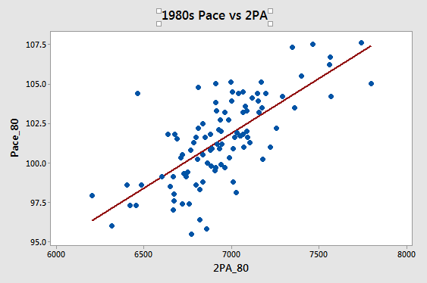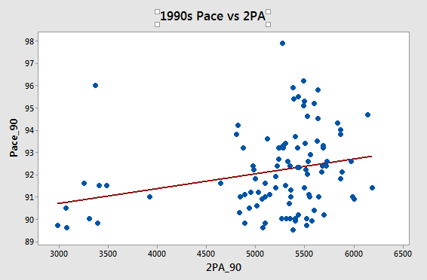

As you can see from the above graphs, 2PA seems to have, in general, a strong positive correlation from all of the seasons from 1974-1994, signifying that in general, which is also logical, in the same amount of game time, taking more two-pointers would increase the amount of possessions per game and thus increase the average pace of the game.

Because the three-pointer was not introduced in the 1974 season, we were not able to run a regression analysis of Pace vs 3PA in the 1974 season, but we were able to compare the 1984 and beyond seasons. For the 1984, 1994, and 2004 seasons, we obtained R2 values of 0.029, 0.0656, and 0.0326, respectively. So, if we look at this data, the jump from 1994 to 2004 is similar for the 3PA one as well as the 2PA, AST, ORB jump. So, the three pointer was most likely not the cause of the decrease in importance of the shot, but was most likely also affected by the decrease of importance of the shot in general on the pace. However, if we compare the 1984 R2 value of 2.9% to the 1994 value of 6.56%, the importance of the 3PA attempt on Pace increased from 1984 to 1994. This is the opposite trend from the regression analysis of 2PA, AST, ORB importance, in which the R2 value decreased from 55.29% to 49.49% from 1984 to 1994. This difference in trend could be related, in that as the 3 point attempt affected the pace more, the other statistic such as 2PA, ORB, and AST affected the pace less.

Below are the regression graphs of Pace vs 3PA for the 1980s and 1990s decades: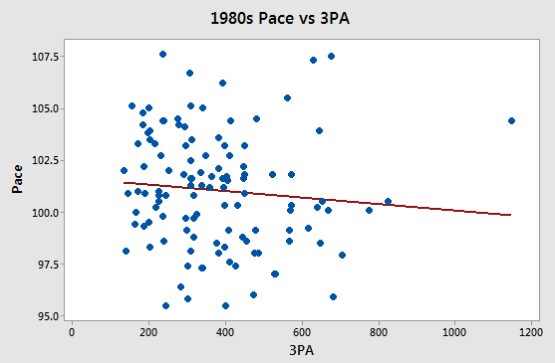

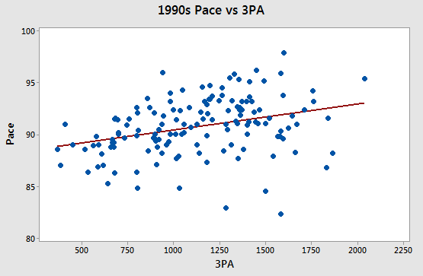

We can see from the above graphs that there is a negative correlation in the 1984 season between Pace and 3PA, while in the 1994 season, there was a positive correlation between Pace and 3PA. This tells us that in 1984, 3PA was not as important to Pace, and actually, taking more 3PA would decrease the pace of the game in general. Conversely, in 1994, 3PA impacted Pace more, and taking more 3 point attempts would increase the pace of the game and the number of possessions per game.

Now, let us look at the weird decade, 2000s. Below are the regression graphs for Pace vs. 2PA: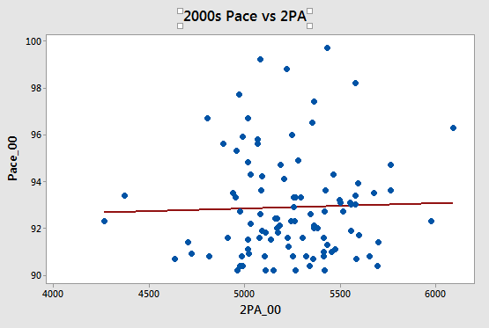

This graphs is very interesting, because it seems like 2PA has a very small, if almost 0, correlation with the Pace, signifying that the pace was not very affected by the amount of 2 point attempts by each team. This was also seen in 3PA, and in general, for some reasons, the amount of shots did not really impact the Pace as much. We are not exactly sure why this is.

When we ran T-Tests comparing the Pace of the different decades and seeing if it was significantly different every time, we got the results:

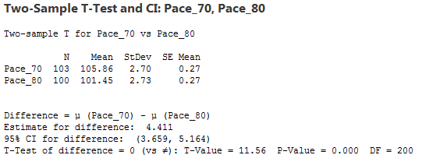

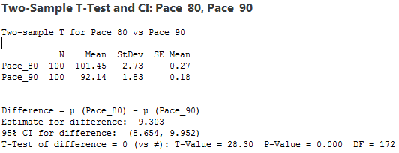

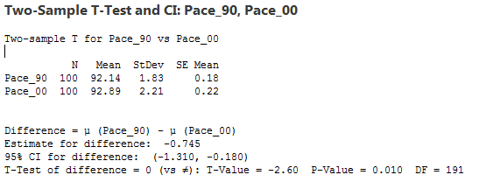

For each comparison in decade, 70s vs. 80s, 80s vs. 90s, and 90s vs. 00s, by taking a 2-sample T-test, the p-value was extremely small each time, p<0.05. So, we determined that the pace was significantly different in each decade. What propelled this change is what we are not 100% sure about, but with our previous looks at the correlations between 3PA, 2PA, and Pace, the 3PA did have an impact on the pace of the game, significantly changing it from 1974 to 1984, and 1984 to 1994 as it became more common. From 1994 to 2004, the pace was different mostly likely because of some outside factor in the game.

**Conclusion:**

Overall, we were able to conclude that the inclusion of the three point shot did in fact have an affect on the Pace of basketball games. We initially hypothesized that the addition of the three point shot would make the game faster, but this was not the case. The mean of Pace actually dropped by decade and seems to have hit a asymptote of sorts at 92, meaning 92 possessions per game. However, the 3 point shot did not explain as much of the variation in Pace as we initially believed. When the three point shot was first instituted, it was rarely used so most of the variation due to pace was due to the two point shot. Slowly, the three point shot’s effect on the pace of the game increased as the two point shot’s effect on the pace of the game decrease. Then in the 1990s decade, none of the shots had much of an affect on the variation in the pace of the game. Why? We are not entirely sure, but it certainly would make another interesting topic of research.

We would like to say that it is terrible we cannot analyze data sets from today, as it would be inconsistent with our data set requirements. Players like Stephen Curry, James Harden, and Kevin Durant are a large part of the reason we even considered this project. They are constantly pushing the boundaries of basketball and making the game evolve at a rate never seen before. The game of basketball is constantly changing, making feats achieved by old legends seem really great. Who knows how we will consider the today’s best players twenty years from now?